**Employee Attrition Analysis Dashboard Report**

Date: [9th August 2024]

Author: [Dhrupal Patel]

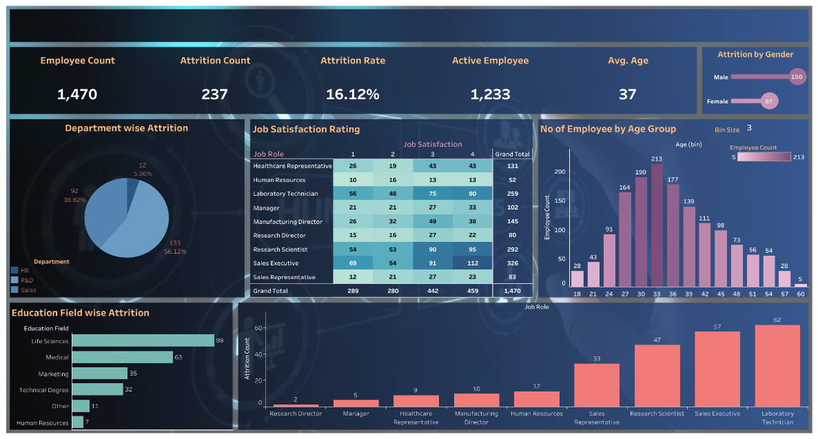

**1. Executive Summary**

This dashboard provides an in-depth analysis of employee attrition within the organization. The key metrics presented include the total number of employees, attrition count, attrition rate, active employees, and average age of employees. The analysis delves into attrition by department, education field, job role, age group, and gender.

Key Insights:

The overall attrition rate is 16.12% with 237 employees having left the organization.

The R&D department experiences the highest attrition rate at 56.12%.

Laboratory Technicians have the highest attrition count among job roles.

Attrition is most prevalent among employees aged 33 years.

**2. Introduction**

Employee attrition is a critical concern for organizations, impacting both productivity and morale. This dashboard is designed to provide a comprehensive view of the attrition trends within the organization, helping stakeholders identify areas of concern and develop strategies to mitigate turnover.

**3. Dashboard Overview**

3.1 Summary Metrics

Employee Count: The total number of employees in the organization is 1,470.

Attrition Count: The organization has lost 237 employees.

Attrition Rate: The current attrition rate is 16.12%.

Active Employees: There are 1,233 employees still active in the organization.

Average Age: The average age of employees is 37 years.

3.2 Department-wise Attrition

The pie chart indicates that the R&D department faces the highest attrition with 133 employees leaving, which constitutes 56.12% of the total attrition. The Sales department has the second-highest attrition rate at 38.82%, followed by HR with 5.06%.

3.3 Job Satisfaction Rating

The heatmap presents the distribution of job satisfaction ratings across different job roles. Notably, Sales Executives and Laboratory Technicians have a higher concentration of employees with satisfaction ratings of 3 and 4, yet these roles also see significant attrition.

3.4 Attrition by Gender

The dashboard shows a gender-wise breakdown of attrition, with 150 males and 87 females having left the organization. This data is represented through a dual-coloured bar chart.

3.5 Number of Employees by Age Group

The bar chart reveals that most employees fall within the 33 to 39 age range, with the highest attrition occurring at 33 years.

3.6 Education Field-wise Attrition

A horizontal bar chart displays that employees from Life Sciences and Medical fields have the highest attrition rates, with 89 and 63 employees leaving, respectively.

3.7 Job Role-wise Attrition

The bottom bar chart shows that Laboratory Technicians have the highest attrition count, followed by Sales Executives and Research Scientists.

**4. Detailed Analysis**

4.1 Department-wise Insights

The high attrition in the R&D department suggests a need for targeted retention strategies, potentially involving job role enrichment or enhanced career development opportunities.

4.2 Job Satisfaction Analysis

There is a notable discrepancy between job satisfaction ratings and attrition rates in certain roles, indicating that other factors such as workload or job stress may contribute to turnover despite moderate satisfaction levels.

4.3 Age Group Insights

The peak attrition at age 33 may be tied to career transitions or life changes, suggesting that retention efforts could focus on providing career advancement opportunities around this age.

4.4 Education Field Insights

The higher attrition rates in Life Sciences and Medical fields could reflect industry-wide trends or competitive job markets, suggesting a need for benchmarking and possibly revising compensation structures.

**5. Conclusions**

The dashboard provides critical insights into areas where the organization is most vulnerable to attrition. High turnover in specific departments and job roles points to underlying issues that require attention.